SVM:
- In machine learning, support vector machines are supervised learning models with associated learning algorithms that analyze data used for classification and regression analysis
- It is mostly used in classification problems. In this algorithm, we plot each data item as a point in n-dimensional space (where n is number of features you have) with the value of each feature being the value of a particular coordinate. Then, we perform classification by finding the hyper-plane that differentiate the two classes very well
- maximizing the distances between nearest data point (either class) and hyper-plane will help us to decide the right hyper-plane. This distance is called as Margin
- SVM selects the hyper-plane which classifies the classes accurately prior to maximizing margin.
- SVM has a feature to ignore outliers and find the hyper-plane that has maximum margin. Hence, we can say, SVM is robust to outliers.
- Pros:
- It works really well with clear margin of separation
- It is effective in high dimensional spaces.
- It is effective in cases where number of dimensions is greater than the number of samples.
- It uses a subset of training points in the decision function (called support vectors), so it is also memory efficient.
- Cons:
- It doesn’t perform well, when we have large data set because the required training time is higher
- It also doesn’t perform very well, when the data set has more noise i.e. target classes are overlapping
- SVM doesn’t directly provide probability estimates, these are calculated using an expensive five-fold cross-validation. It is related SVC method of Python scikit-learn library.
- Kernal Trick: A kernel is a similarity function. It is a function that you, as the domain expert, provide to a machine learning algorithm. It takes two inputs and spits out how similar they are. Suppose your task is to learn to classify images. You have (image, label) pairs as training data.
- Svm C parameter - controls tradeoff between smooth decision boundry and classifying training points correctly.
Largevalue of C means we are going to get more training point correct but it doesn’t means that acuracy increases.
- Svm gamma parameter :-
- Avoid overfitting of graph in machine learning

Decision Tree
- Entropy -> controls how a DT decides where to split the data.
Defn - measure of impurity in bunch of examples.
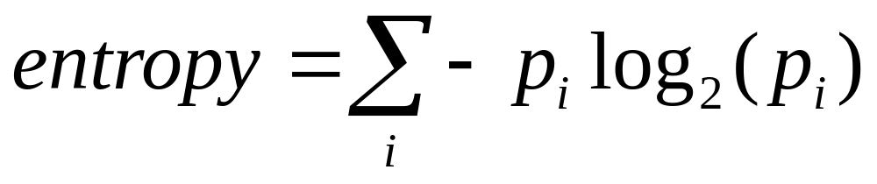
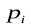
- fraction of example in a given class
entropy is opposite of purity
eg. All examples are same class then entropy = 0
examples are evenly distributed between class entropy= 1
- Information gain
information gain = entropy(parent) - [weighted average] entropy(children)
decision tree algorithm: maximize information gain
- decision tree identifies the most significant variable and it’s value that gives best homogeneous sets of population
K-nearest neighbour:
- k-nearest neighbors algorithm. In pattern recognition, the k-nearest neighbors algorithm (k-NN) is a non-parametric method used for classification and regression. In both cases, the input consists of the k closest training examples in the feature space.
Why is Overfitting bad?
In overfitting, a statistical model describes random error or noise instead of the underlying relationship. Overfitting occurs when a model is excessively complex, such as having too many parameters relative to the number of observations.
One way to understand that intuitively is that a model may use some relevant parts of the data (signal) and some irrelevant parts (noise). An overfitted model uses more of the noise, which increases its performance in the case of known noise (training data) and decreases its performance in the case of novel noise (test data). The difference in performance between training and test data indicates how much noise the model picks up; and picking up noise directly translates into worse performance on test data (including future data).
Summary: overfitting is bad by definition, this has not much to do with either complexity or ability to generalize, but rather has to do with mistaking noise for signal.

Continuous supervised learning:

